
Faculty of Science and Engineering

Department of MATHEMATICS AND COMPUTER SCIENCE

Assessment Brief

Module | 5cs045 – Full Stack Development
Module Leader | Alix Bergeret
Semester | 1
Year | 2025-2026
Assessment Number | 2
% of module mark | 100%
Due Date | See below
Hand-in – what? | See below
Hand-in- where? | See below
Pass mark | 40%
Method of retrieval
Feedback | Face to face demonstration
Collection of marked work | See below

Learning outcomes:

LO1 Demonstrate knowledge of the concepts, approaches and technologies involved in dynamic website construction, full-stack development and web security.

LO2 Be able to design and construct dynamic and secure full-stack websites using appropriate tools and technologies.

Your portfolio is made up of 2 tasks:

- In tasks 1, you are expected to code a simple PHP script in time-constrained conditions (i.e. a test)
- In task 2, you are required to build a secure, dynamic website featuring the technologies taught in the lectures.

Please see below for a detailed description of each task.

Choose a topic

The topic of your site can be any of your choosing. Pick something you have an active interest in, a hobby, a sport you play, a group or club you belong to, or any similar topic. Once you have selected your topic YOU MUST CONFIRM THIS WITH YOUR TUTOR. You will not be allowed to proceed with your topic of choice without tutor agreement. You may not change your topic without further consultation with your tutor.

Task 1 – Database creation and PHP access
When: Week 05 during the usual workshop session
Weight: 30%

You will have 1 hour to perform various coding tasks in a time-constrained environment.

Topics included:
- Basic PHP programming concepts
- Creating a table in MySQL via phpMyAdmin
- Accessing a database from PHP and retrieving/displaying/formatting data
- Committing work to Git.

Learning resources

During the test you will have access to the following resources:
- https://mi-linux.wlv.ac.uk/wiki/index.php/PHP
- http://www.w3schools.com/

Tools

Your site must be coded in a simple text editor, such as Notepad++. You cannot use any CMS, Web Frameworks, or similar tools to construct your site. The use of any tools which construct any part of the website for you is strictly forbidden – usage of these tools will result in a FAIL grade. If you are in any doubt about whether the tool you wish to use is not acceptable, speak to your tutor BEFORE you begin to construct your site.

Submitting and presenting your work

You should submit to Canvas a single Word document containing the following information:
- Your student ID
- Your name
- The URL to your work, hosted on mi-linux
- The URL to your Git project to which you have committed your work.

Rubric

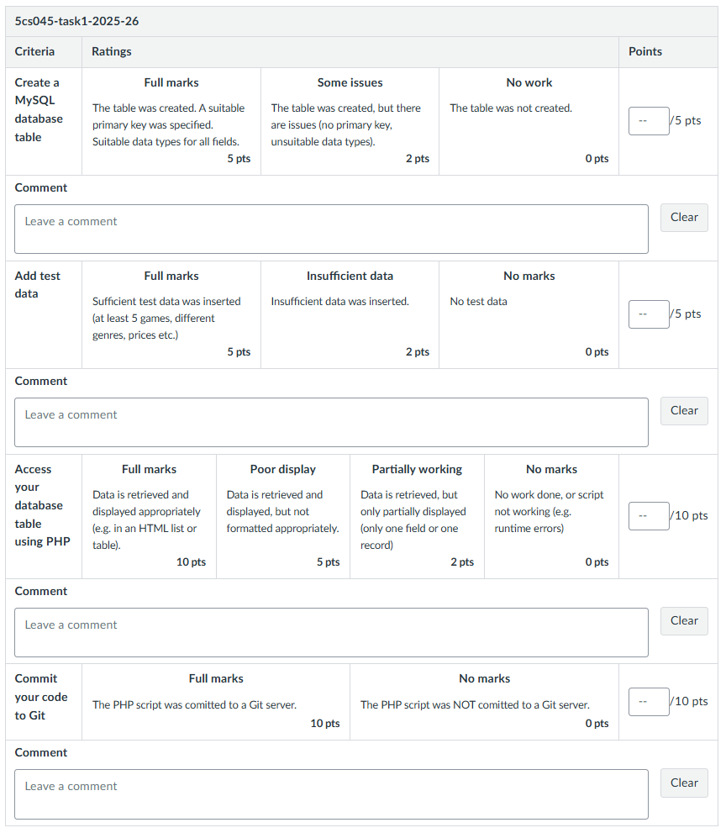
Task 2 – Full site implementation
Due date: Friday, week 11
Weight: 70%

Full site implementation

Please submit a fully working website, keeping in mind the following points:

- Your website must be developed using PHP and Mysql, and hosted on the school’s student server.
- Users should be able to read, add, amend and delete records stored in your Mysql database.
- Users should be able to search for records stored in your MySQL database (extra points will be earned if searches on several criteria are possible, e.g. list all Sci-Fi books published in 2023)
- Your website should be protected against the most common security threat (XSS, SQL Injection etc.).
- Ajax has been used to provide useful functionality (e.g. autocomplete search, form filling assistance etc.)
- Extra points will be earned if a template engine was used to separate client-side markup from server-side logic.

See rubric below for more information.

Submitting and presenting your work

The work above should be published on the school’s student web server, and presented to a tutor during workshop hours. You should also submit the URL of your website to Canvas.

The Demonstration

You must attend and demonstrate your website to a tutor. This demonstration is your opportunity to highlight the best areas of your work, and to answer any questions that the workshop tutor might have. You will be given feedback on your assessment during this demonstration.

The lecturer will also use this session to assess whether the work presented was created by the student:
- Technical questions about the work will be asked.
- Attendance records will be consulted.
- Git commit logs will be checked.

If the points above are not satisfied, a grade of 0 will be awarded.
Important: You only get one chance to present.

A booking system will be provided. It is your responsibility to have booked an appointment to demonstrate your work.

Failure to present your work will result in a grade of 0 NS (FAIL) for the assessment.

Rubric

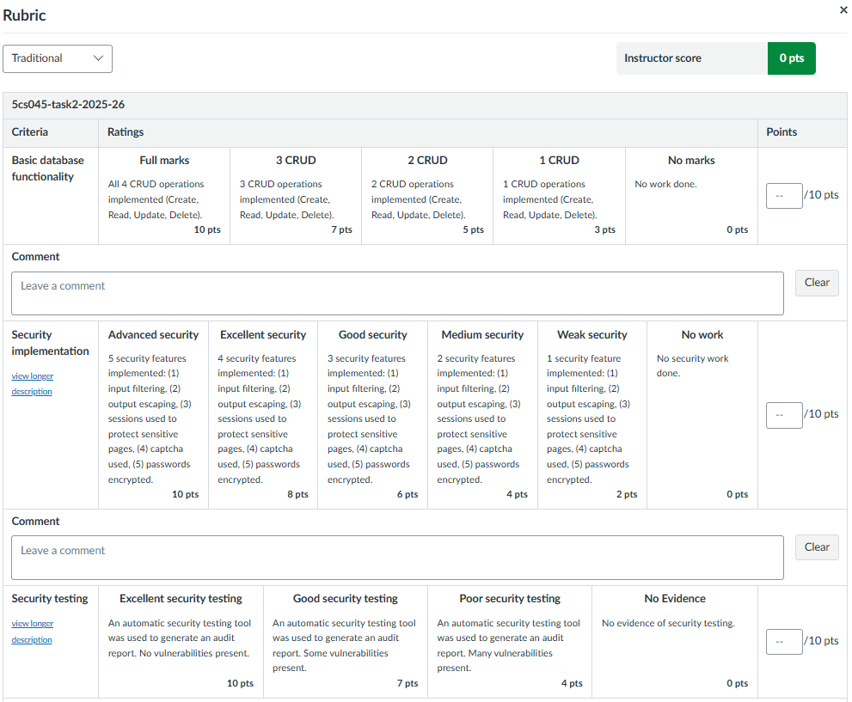

The second half of the rubric is located on the next page.
